Sumilarv 0.5G – Dosing Cheat Sheet
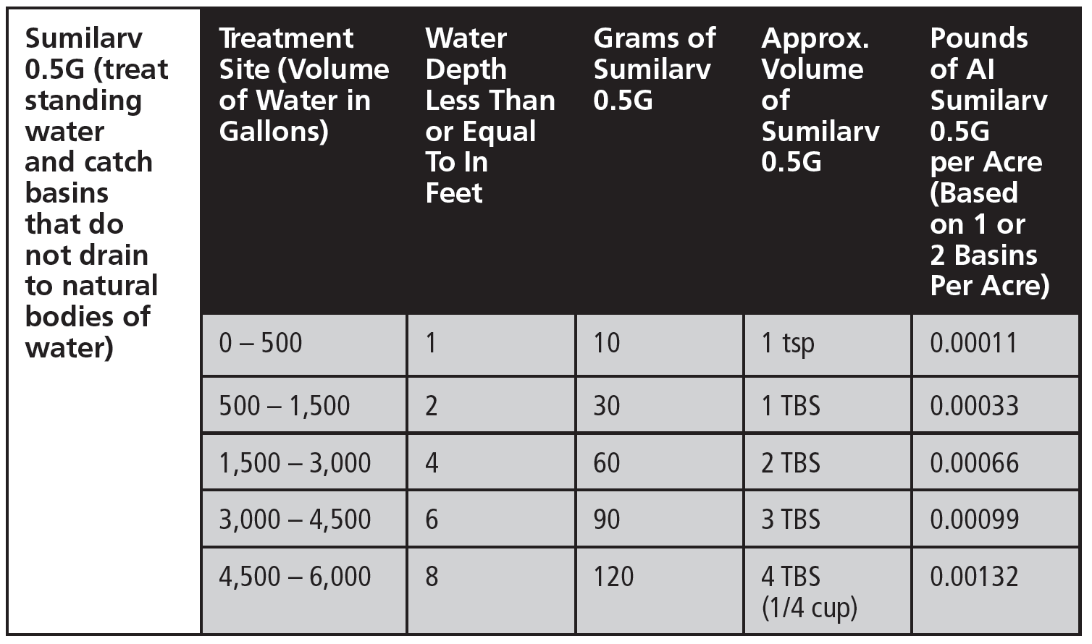

Sumilarv 0.5G – Dosing Cheat Sheet

